Kids and Poverty
Student’s Name
Institution

Kids and Poverty
Picture 1
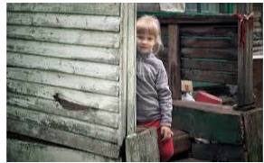
The picture represents a child living in an impoverished house, as evidenced by the deplorable condition of the house. It is no doubt that the kid comes from a humble family with meager earnings. The state of lifestyle she leads portrays that her family is poverty-stricken (Schaefer, Mattingly, & Johnson, 2016). The humble abode where the child lives is degraded, as seen by the discolored woods. Hence the picture inevitably tells that the kid lacks a proper shelter to live in. The lifestyle led by the child is detestable as it is difficult for her to get the basic human needs such as adequate foods, clothing, and proper education.
Picture 2
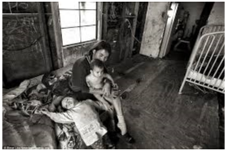
The photo represents a woman with her two kids living in a poorly maintained building. They live in poverty, which is depicted in different ways. Foremost, they do not have proper shelter for living. The house is deplorable, as seen by its impoverished state. For instance, the refrigerator has become stained, and the room looks disheveled. The home is not well-organized and lacks essential materials like chairs and tables to be considered appropriate for inhabitation. The children in the company of their mother live in poverty. Also, the children look malnourished, as denoted by the poor lifestyle they are living.
Summary of the theme of Kids and Poverty
The two photos portray the impoverished states of lifestyles led by kids coming from low-income families. They live in humble abodes and lack the basic essential for proper living such as good shelter, clothing, and enough food.
Social class influences the life choices for the individuals in the photos. In picture 1, being that the kid is from a low-income family, she cannot access various opportunities enjoyed by those coming from high-income families (Jacob, & Boyd, 2020). Therefore, she cannot get access to better education and adequate food. Also, the kids in picture 2 hail from a low income earning family, making it difficult for them to acquire proper education, good shelter, and sufficient food a preserve for high-income earning individuals. Social class has a considerable impact in shaping the kind of lifestyles the individuals in the pictures lead. The kids are from low-income families, and this dictates the lifestyle they lead – poverty.
In conclusion, poverty refers to the state of lacking the financial resources as well as essentials required to attain a minimum standard of living. Contemporarily, in the US, about 15 million children reside from families earning lower incomes – below the federal poverty brink. From the photo essay assignment, I learnt that many children in America still live impoverished lifestyles as they lack basic human needs like enough food, proper shelter, and clothing.

References
Jacob, A., & Boyd, R. (2020). Addressing economic vulnerability among low-income families in America: is the basic income approach a viable policy option?. Journal of Children and Poverty, 1-15.
Schaefer, A. P., Mattingly, M. J., & Johnson, K. M. (2016). Child poverty higher and more persistent in rural America.

